Cool self-assembling robots

Req:
- Smallish
- Can tell orientation (accelerometer?)
- Can communicate between each other (wifi/Bluetooth?)
- Can dock to one another (electromagnets?)
- Shape (square/triangle? Must be able to build solid shapes) (octahedron style for easy manoeuvring around one another?)
- Can orient/move relative to each other (motors/magnets)
- Master/slave units (allow sending commands to master)

How will it move
- Wheels
  - For traversal, only allows for translational motion
- Flywheels
  - Allows for inertial rotational motion, can make non-spherical objects “roll”. Needs a motor and flywheel for each axis.
How can we tell orientation
- Accelerometer (measures linear velocity)
  - Accelerometers measure acceleration in one direction, by adding one to each axis linear forces can be determined. A 3-axis unit can also be used.
- MEMS Gyroscope (measures rotational velocity)
  - Gyroscopes measure angular velocity. This is measured in all axes, so one unit is used to find all velocities.
- Magnetometer (measures heading like a compass)
  - Magnetometers, measure heading as an angle from north. Using two can be used to find horizontal orientation.
Communication
- Bluetooth
  - Shorter range
  - Easier connection
  - Slower data rate (3mbps)
  - May be a better use case for communication between bots
- Wi-Fi
  - Long range
  - Allows for a direct internet connection
  - Fast data rate (up to 10gbps)
  - More suitable for connection between bot and host
Processing
- ESP32
  - Well known so lots of documentation
  - Easy to use, similar to Arduino
  - Lots of features, including Bluetooth and wifi
  - Ideal for main agent, allows for wifi to pc and Bluetooth to other bots
PCB Design Software
- KiCad
  - Big backing
  - Completely free
  - Lots of support
  - Lots of learning material
- Altium Designer
  - Professional software
  - Free education license
  - Lots of learning materials
  - Not suitable without license

Shape options
- Cube
  - Simple
  - Large angles
  - Easy to fit electronics
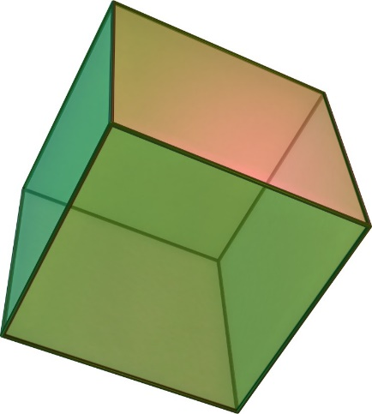
- Octahedron
  - Simple
  - Angles can be inconsistent
  - Like cube with smaller angles
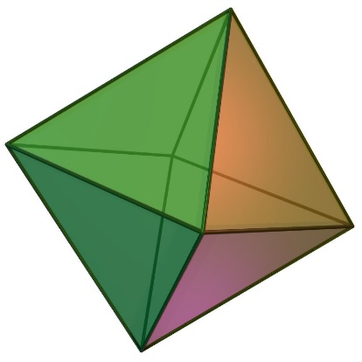
- Icosahedron
  - More complex
  - Small angles between faces
  - More docking ability needed
